Table of Contents

Python Anywhere Introduction 1

Build the Django Application 1

Hosting on GitHub 2

Download from GitHub to Python Anywhere 5

Prepare a Virtual Environment 6

Configure the Project 6

## Python Anywhere Introduction

Python Anywhere at <http://pythonanywhere.com> allows you to host Django, Flask and Python notebooks for free without a credit card. You can host items for 3-months and extend your hosting time by logging in prior to the expiry date and clicking the orange button shown in Figure 1.

Figure : Python Anywhere dashboard (left) and live application (right).

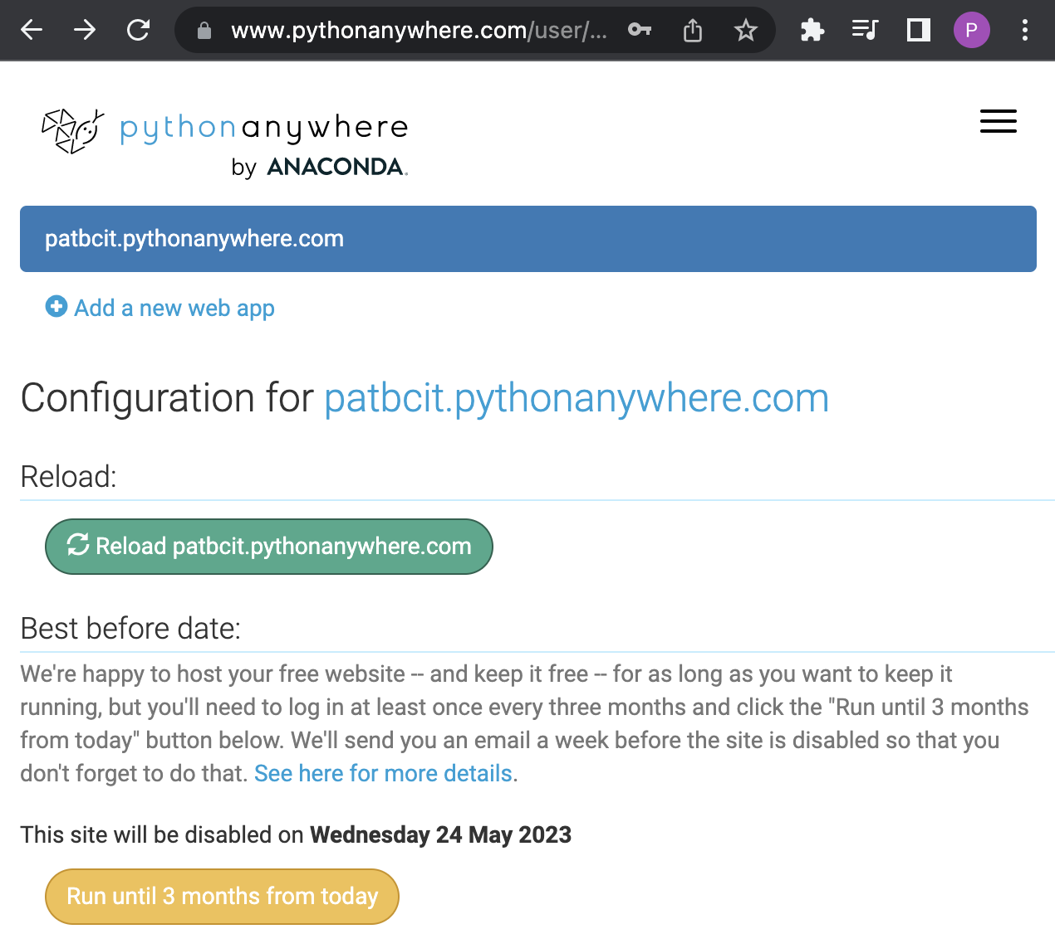 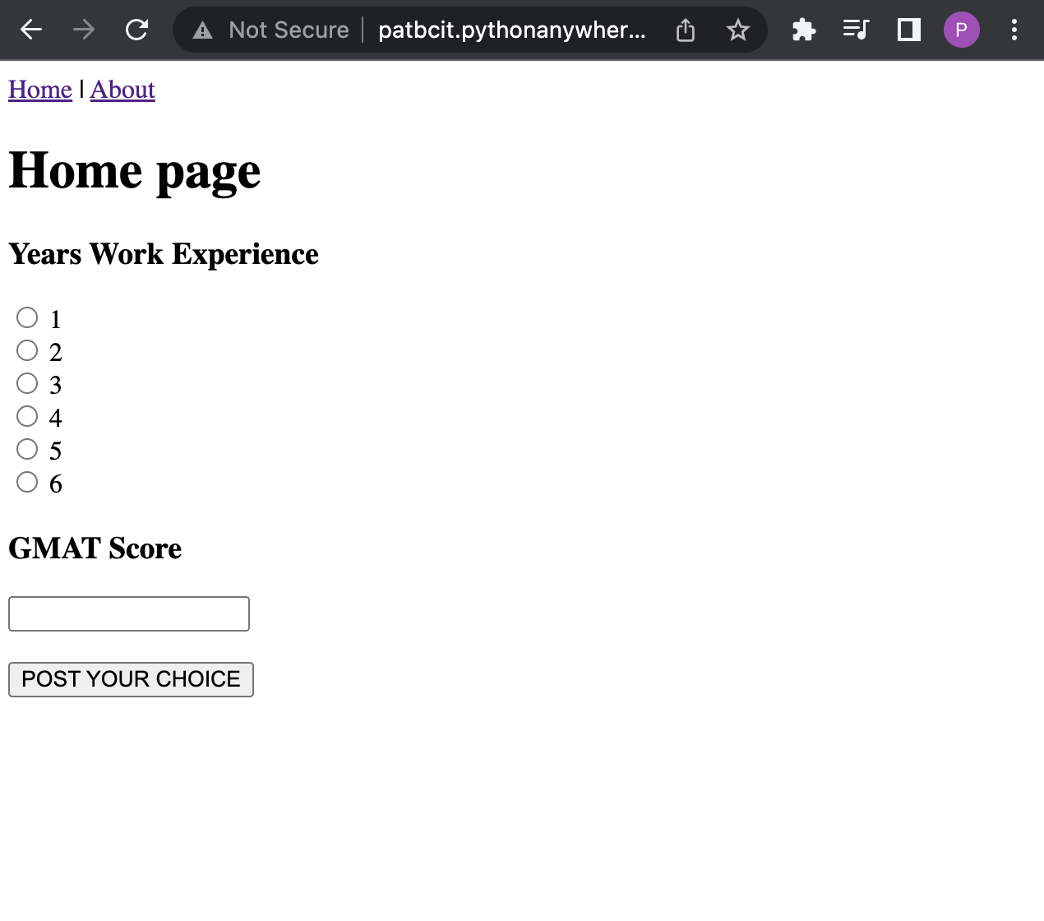

I have not explored the hosting of Flask or Notebooks yet but will and I hope to cover this in class soon (maybe Thursday next week).

The steps for hosting an application on Python Anywhere presented in this document are based on the tutorial at <https://help.pythonanywhere.com/pages/DeployExistingDjangoProject/>

The tutorial online offers other detail that may be helpful or of interest.

## Build the Django Application

This lab starts with the completion of lesson week 8. For ease of use, completing the solution in lesson 8 that is presented exactly will make the deployment much easier. Here is a screenshot of my application which is running locally. The application allows users to submit their work experience and GMAT score. The binary model on the server side receives the input and makes a prediction about the user being admitted to College. The response is then displayed to the user.

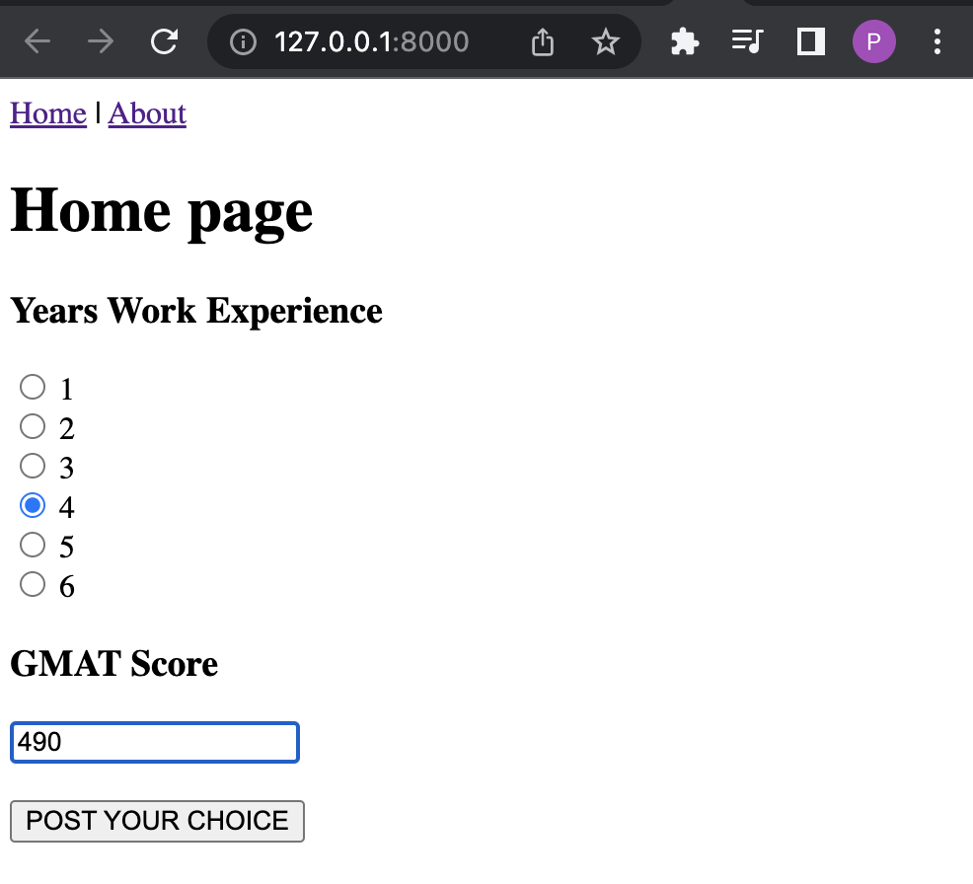 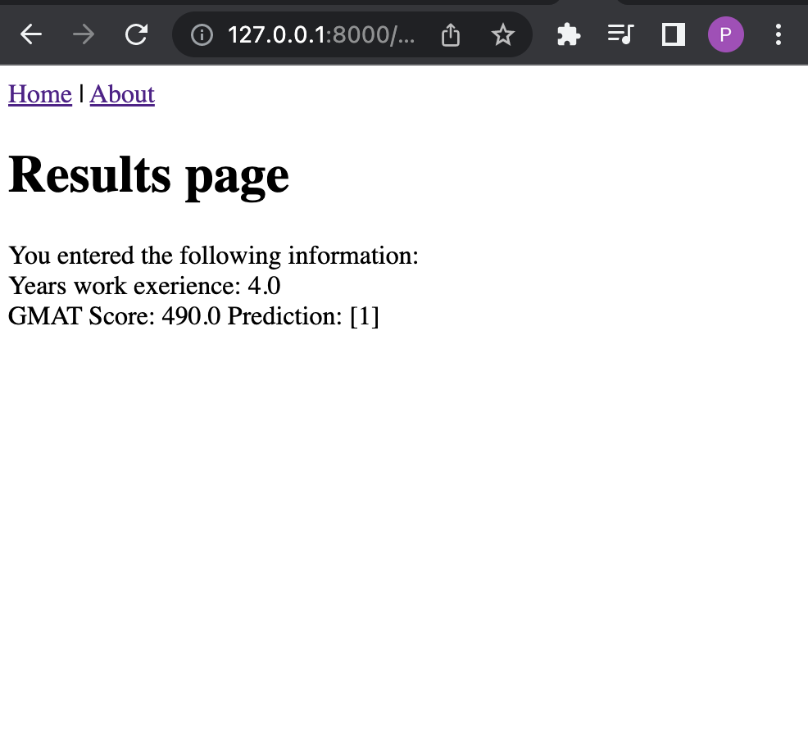

## Hosting on GitHub

The option that I used to transfer my application to Python Anywhere involves cloning my GitHub repository from GitHub to Python Anywhere. There are other ways to upload your code but so far this is the only method that I could get to work.

Example : Hosting your Local Python Project on GitHub

This example shows steps needed to host the Python College admission solution at GitHub.com. I experienced authentication issues at several steps along the way. To help eliminate authentication trouble, I created a public repository called helloworld at GitHub.



I also used GitHub Desktop which can be downloaded from <https://desktop.github.com/>. I recommend doing the same exactly.

Follow the tutorial in lesson week 8 for creating a Django site exactly. Naming will matter. Figure 2 shows the local working solution as it is displayed in PyCharm. Everything except the pickle is contained inside the ***helloworld*** folder. You can ignore the pickle for now.

Figure : Local solution viewed from PyCharm

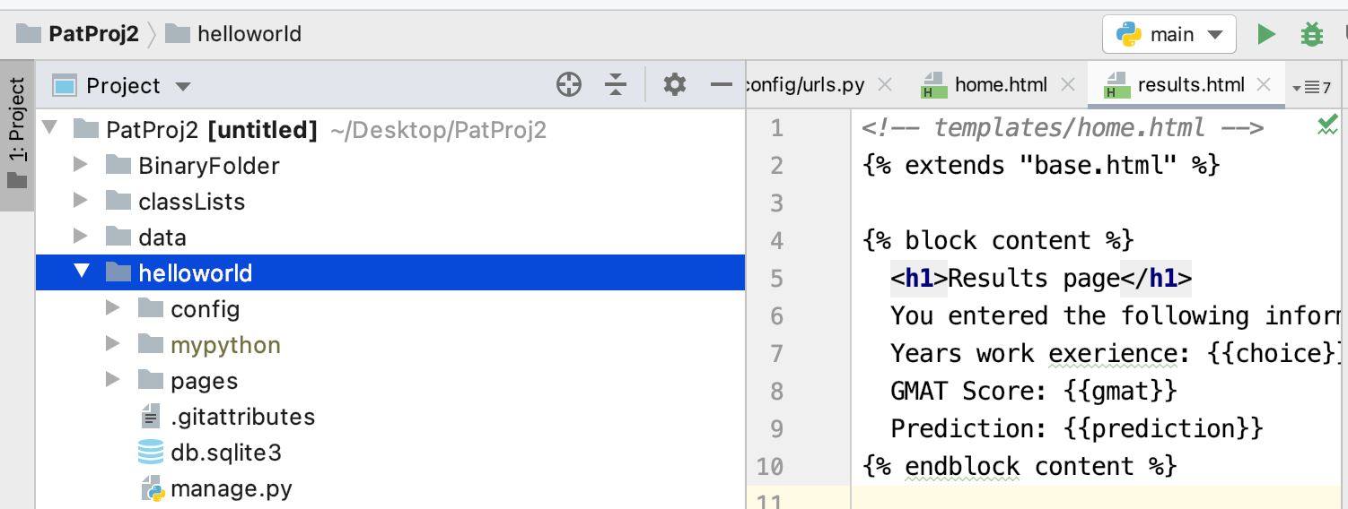

To add the helloworld project to a local repository in GitHub Desktop, click ‘Add an Existing Repository from your Hard Drive’. Then when prompted navigate to the folder where **manage.py** exists. Then click **Open**. (Refer to Figure 3).

Figure : Creating and Initializing a Local Repository in GitHub Desktop



Once the remote repository was created I could get the repository address from GitHub remote from the Code tab.



In GitHub Desktop under Repository | Repository Settings enter the address to your remote repository and choose save.

Then choose **Push Origin** in GitHub Desktop.



Then double check your online repository to ensure the code is present. Make sure also that the manage.py file is visible in the root folder.



## Download from GitHub to Python Anywhere

To download your code to Python Anywhere, in the dashboard of Python Anywhere click on consoles. Then add a console or choose an existing one. You get a maximum of two consoles so you will need to delete them if you exceed the limit.



From there you can clone your repository:

git clone <http://github.com/pmcgeebcit/helloworld.git>

To confirm that the download was successful I ran the command ‘ls’ to display the directory contents.

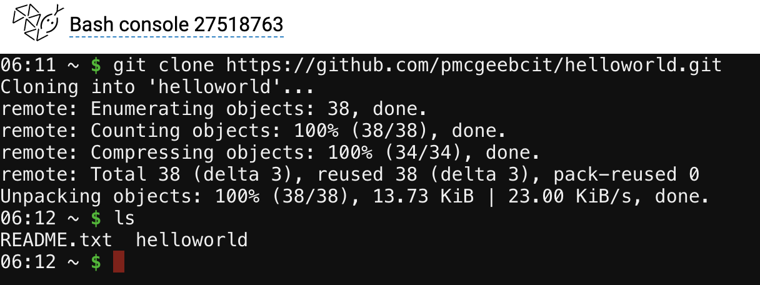

## Prepare a Virtual Environment

The next step involves creating a virtual environment in Python Anywhere. In your Bash console, create a virtualenv, naming it after your project, and choosing the version of Python you want to use. I recommend using this script exactly as shown since naming matters.

**Note**: The install may take a while (15-20 minutes potentially) but sometimes it is faster depending on site traffic.

$ mkvirtualenv --python=/usr/bin/python3.10 mysite-virtualenv

Then install Django inside the virtual environment.

(mysite-virtualenv)$ pip install django

Also install pandas.

(mysite-virtualenv)$ pip install pandas

## Configure the Project

This next step involves project configuration. From the **Web** tab, choose **Manual configuration**. DO NOT choose the “Django” option.



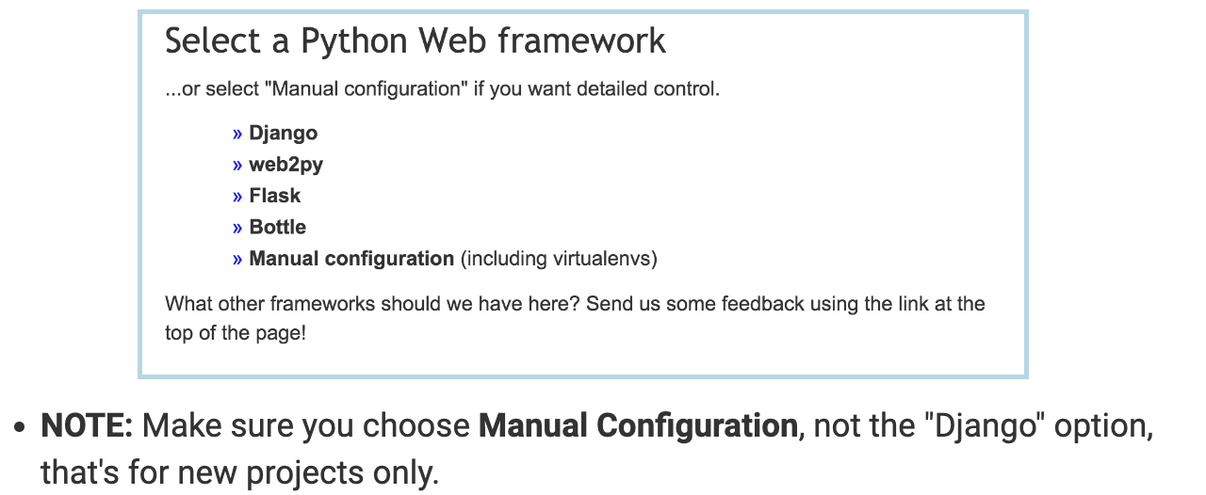

Also on the **Web** tab, you will need to edit your **Source code** directory and **Working directory**.

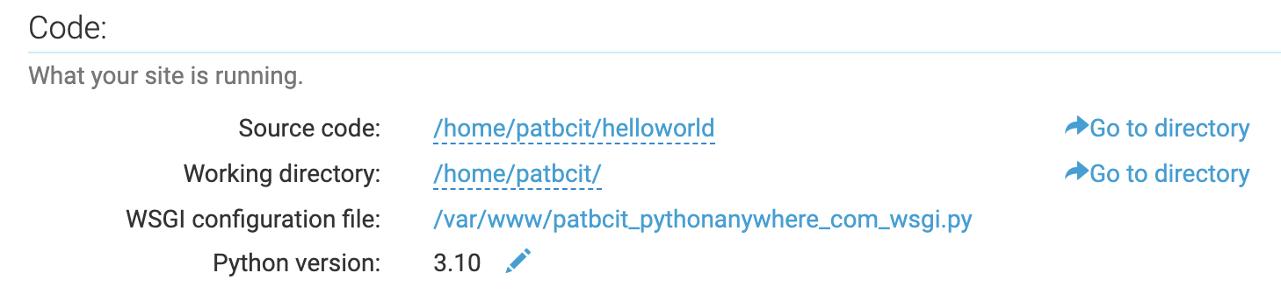

Verify the files exist in the Source code directory and Working directory by clicking on the “Go to directory” link. (I added the static folder later so your build likely will not have one yet)



#### Next edit the WSGI file by clicking the link from the Web tab at Python Anywhere.

#### 

Delete everything except the Django section and then uncomment that section. Your WSGI file should look something like this:



Next, enable your domain access in the settings file. To edit the settings file, go to **/home/yourname/helloworld/config** and click **settings.py**



In the editor, enter your site name in the ALLOWED_HOSTS list.



To avoid issue with the binary file and to ensure the site works so far, this next step will simplify the code in the results() function of views.py. You can get to the views.py file from the **Web** tab by clicking the link to the **Source code** directory and then clicking on **pages/views.py**.



VERY IMPORTANT

You do not need sklearn so remove the import sklearn statement from views.py. Installing sklearn will take too much storage space so do not install it.

Replace the results() function with the code below. Be sure to save your changes after. We will implement the binary model later.



|  |
| --- |
| def results(request, choice, gmat):  print("*** Inside reults()")  workExperience = float(choice)  print("*** GMAT Score: " + str(gmat))  print("*** Years experience: " + str(workExperience))  return render(request, 'results.html', {'choice': workExperience, 'gmat': gmat,  'prediction': -999}) |

Then from the Web tab, click the reload button to ensure the site is updated with the latest changes. After click the link to your site to view the changes.



Your site should now be visible and it should be functional.

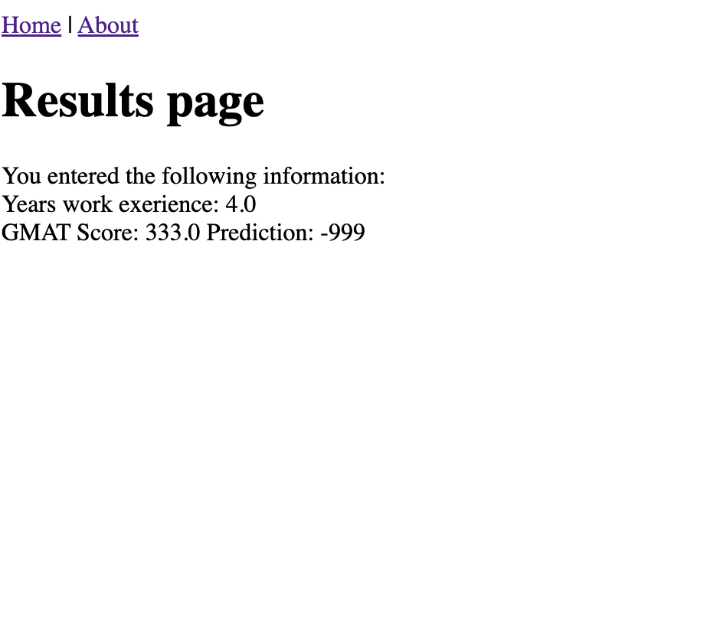

Example : Implementing the Binary Model

To implement the binary model, create a static folder in the root directory of your project.



When inside the static folder upload your binary file.



After, navigate to pages/views.py and replace the results function with the following code. Also update the file path to your project location.

|  |
| --- |
| def results(request, choice, gmat):  print("*** Inside reults()")  # load saved model  with open('/home/patbcit/helloworld/static/model_pkl', 'rb') as f:  loadedModel = pickle.load(f)  # Create a single prediction.  singleSampleDf = pd.DataFrame(columns=['gmat', 'work_experience'])  workExperience = float(choice)  print("*** GMAT Score: " + str(gmat))  print("*** Years experience: " + str(workExperience))  singleSampleDf = singleSampleDf.append({'gmat': gmat,  'work_experience': workExperience},  ignore_index=True)  singlePrediction = loadedModel.predict(singleSampleDf)  print("Single prediction: " + str(singlePrediction))  return render(request, 'results.html', {'choice': workExperience, 'gmat': gmat,  'prediction': singlePrediction}) |

Then from the Web tab be sure to save the changes and to reload the project. After the changes should be visible on the results page which will not show the output of the binary model.

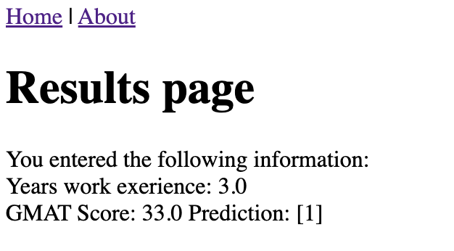

Exercise (10 marks)

Complete the steps in this document. Add text in the HTML to display your name in the output.

Take a screenshot of the page so it shows the pythonanywhere address with your account reference and with your name on the page.



Show your screenshot here:

|  |
| --- |
|  |